**Cloud Computing Lab**

**Nayab Khazin**

**BSE-V B**

**2023-BSE-046**

**LAB 04**

## Task 1 – Verify VM resources in VMware

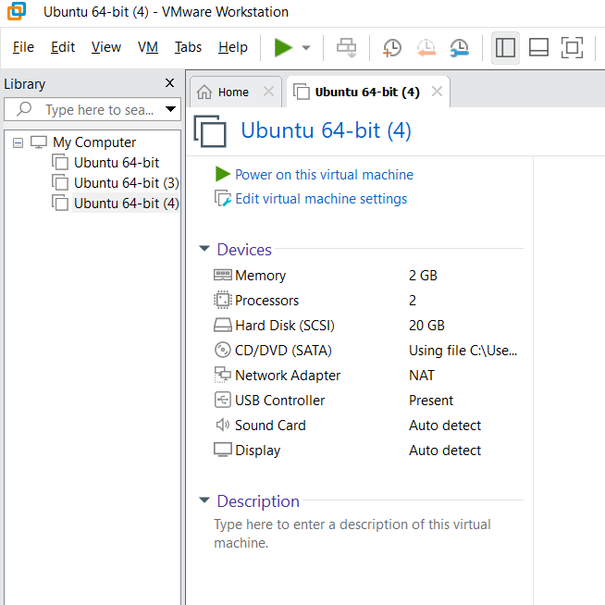

## Task 2 – Start VM and log in (use your preferred host terminal method only)

## vm\_login

## C:\Users\sweng\OneDrive\Pictures\Screenshots\New folder\vm_login.png

## whoami\_pwd

## C:\Users\sweng\OneDrive\Pictures\Screenshots\New folder\whoami_pwd.png

## Task 3 – Filesystem exploration — root tree and dotfiles

* ls\_root.png

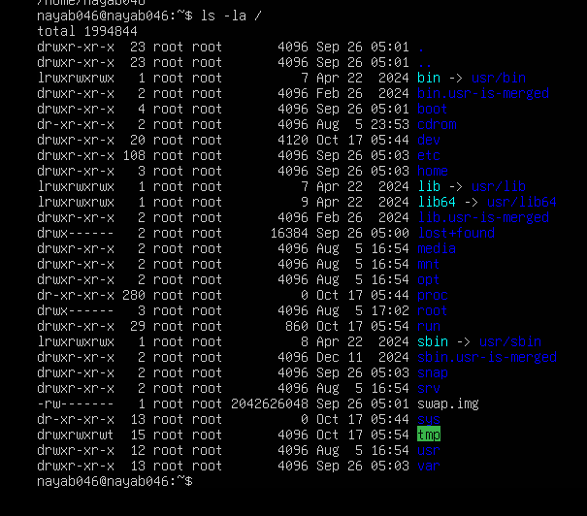

* os\_release.png

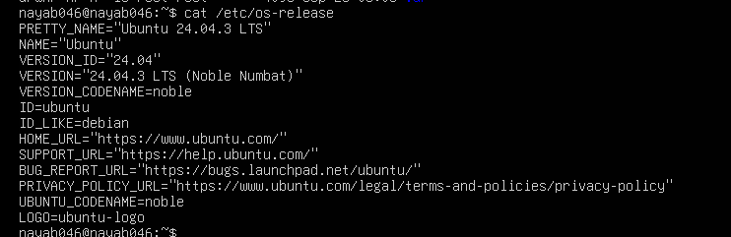

* ls\_bin.png

C:\Users\sweng\OneDrive\Pictures\Screenshots\New folder\ls_bin.png

* ls\_sbin.png

C:\Users\sweng\OneDrive\Pictures\Screenshots\New folder\ls_sbin.png

* ls\_usr.png

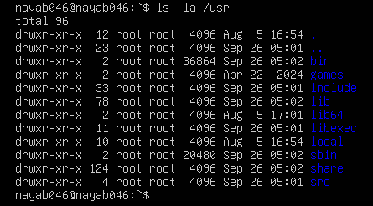

* ls\_opt.png

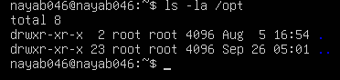

* ls\_etc.png

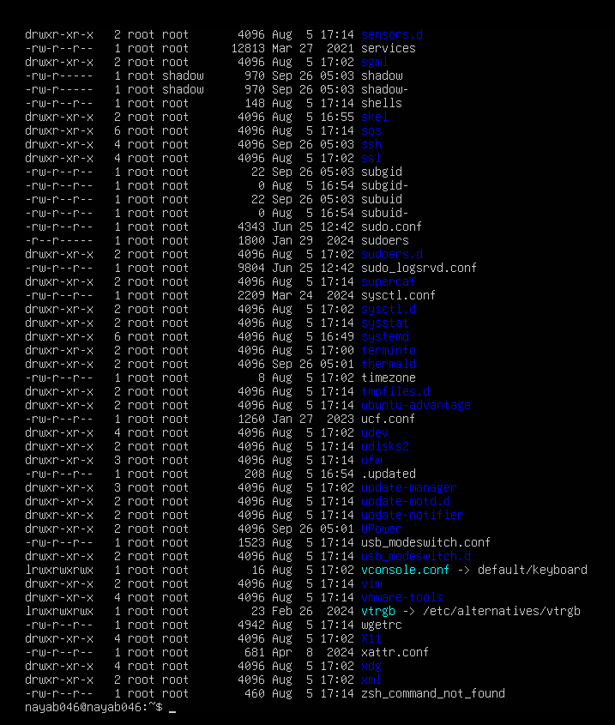

* ls\_dev.png

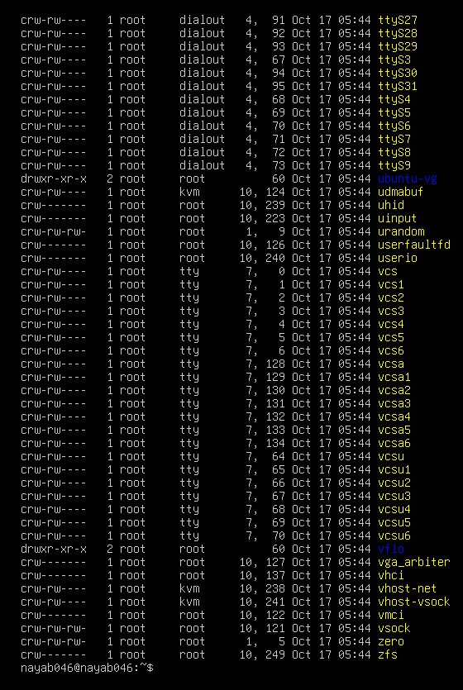

* ls\_var.png

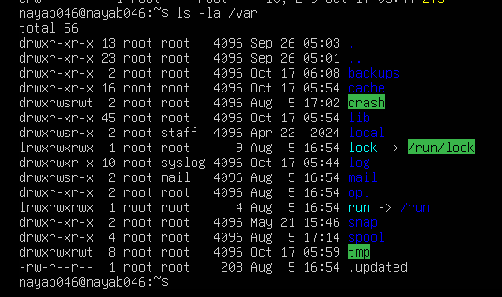

* ls\_tmp.png

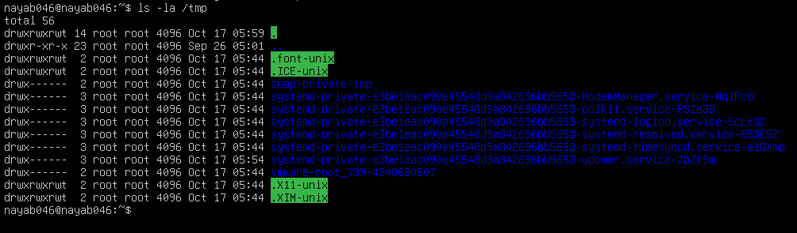

* home\_ls.png

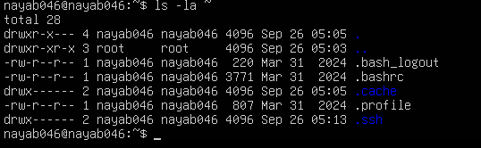

* answers\_md.png

## C:\Users\sweng\OneDrive\Pictures\Screenshots\New folder\answers_md.png

## Task 4 – Essential CLI tasks — navigation and file operations

* mkdir\_workspace.png

C:\Users\sweng\OneDrive\Pictures\Screenshots\New folder\mkdir_workspace.png

* cd\_workspace.png

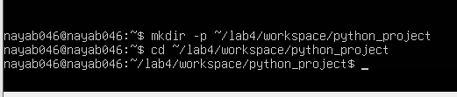

* pwd\_workspace.png

C:\Users\sweng\OneDrive\Pictures\Screenshots\New folder\pwd_workspace.png

* nano\_readme.png

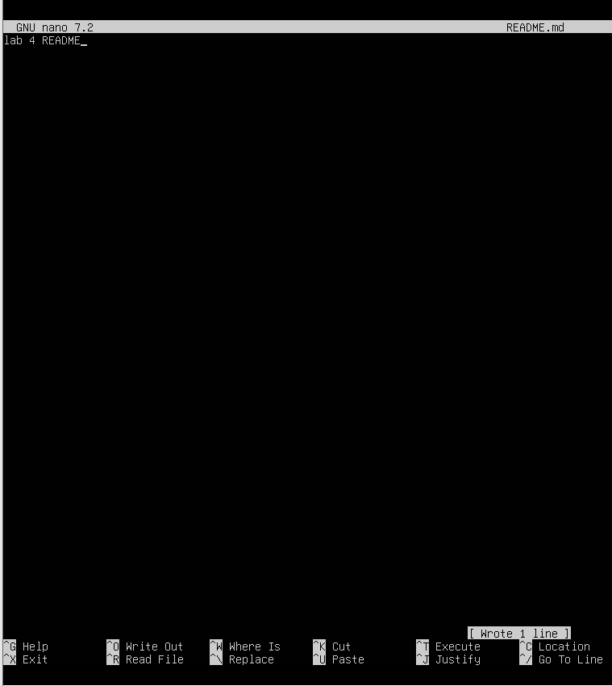

* nano\_main.png

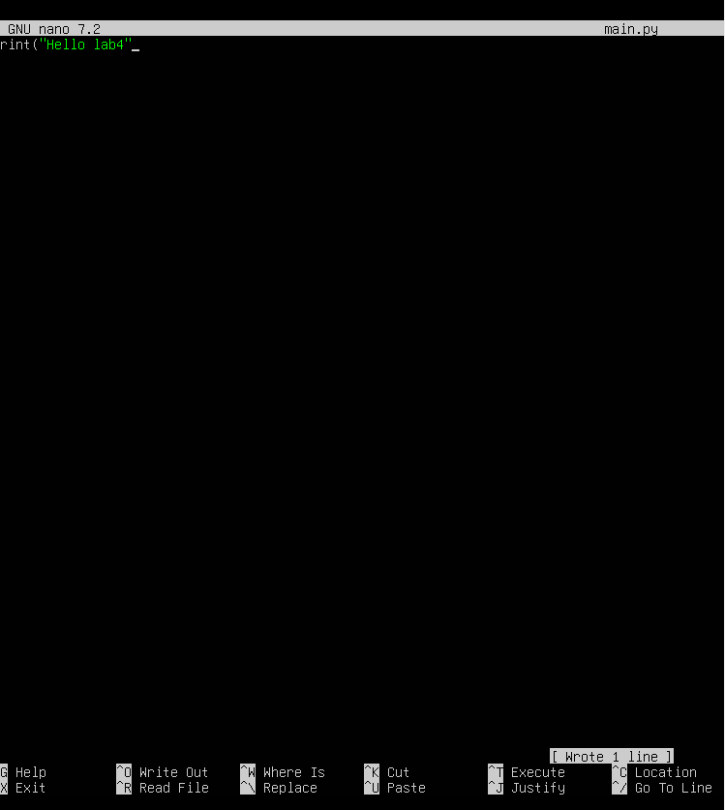

* nano\_env.png

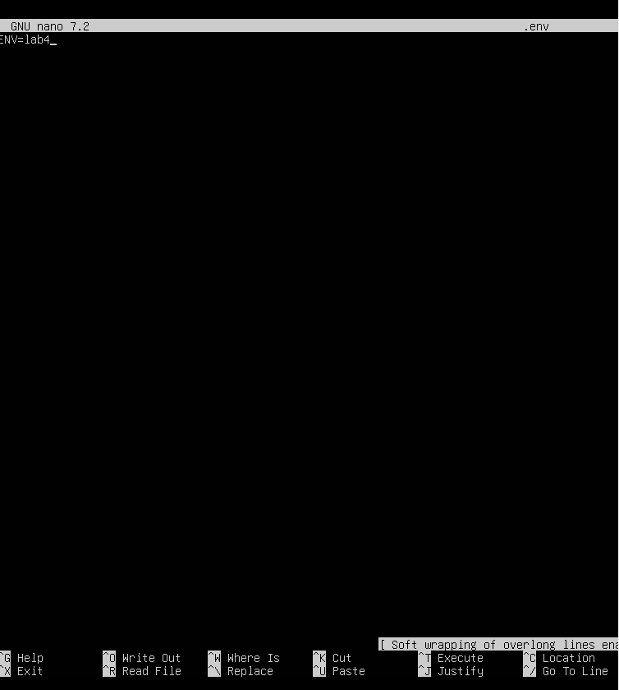

* workspace\_ls.png

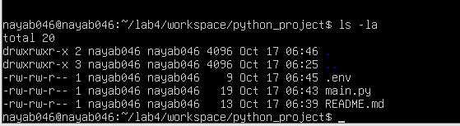

* cp\_readme.png

C:\Users\sweng\OneDrive\Pictures\Screenshots\New folder\cp_readme.png

* mv\_readme.png

C:\Users\sweng\OneDrive\Pictures\Screenshots\New folder\mv_readme.png

* rm\_readme.png

C:\Users\sweng\OneDrive\Pictures\Screenshots\New folder\rm_readme.png

* mkdir\_java\_app.png

C:\Users\sweng\OneDrive\Pictures\Screenshots\New folder\mkdir_java_app.png

* cp\_recursive.png

C:\Users\sweng\OneDrive\Pictures\Screenshots\New folder\cp_recursive.png

* copy\_verify.png

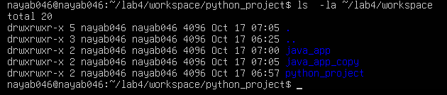

* history.png

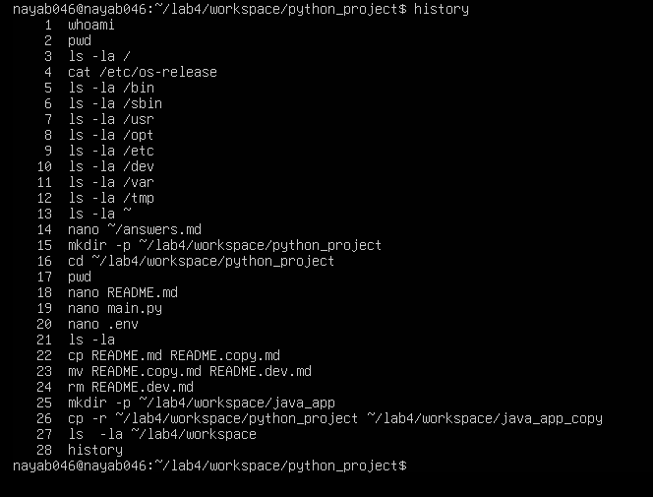

## Task 5 – System info, resources & processes

* uname.png



* cpuinfo.png

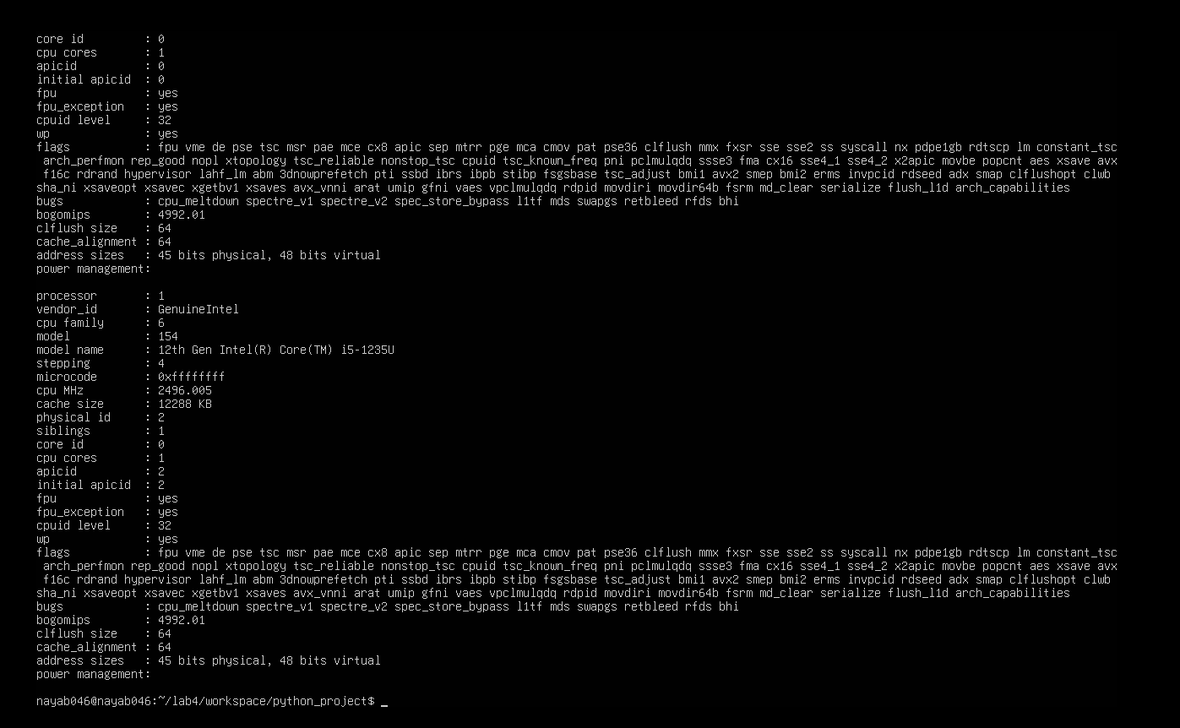

* meminfo.png

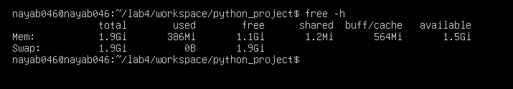

* diskinfo.png

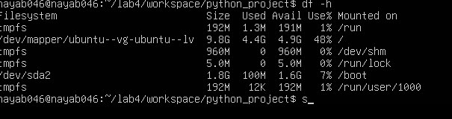

os-release.png

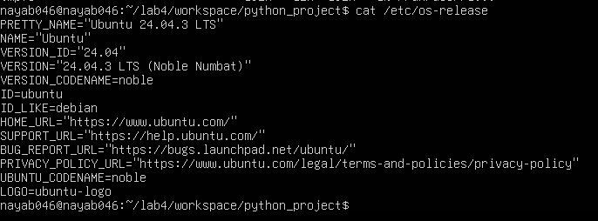

* processes.png

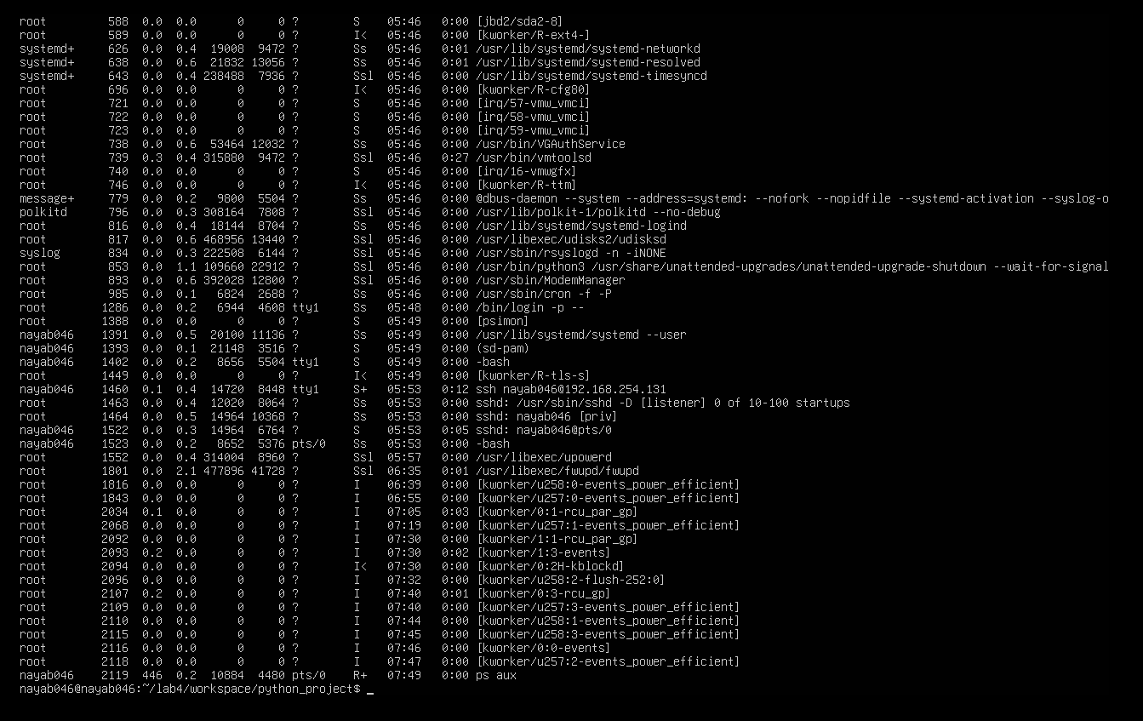

## Task 6 – Users and account verification (no sudo group change)

* adduser\_lab4user.png

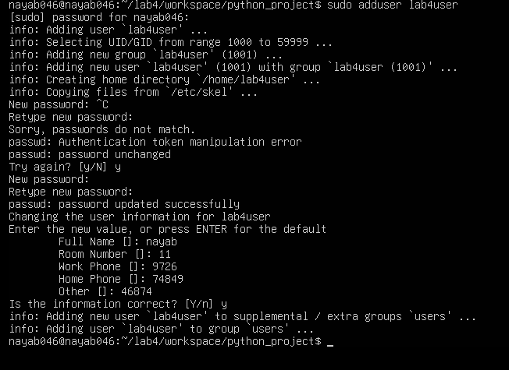

* lab4user\_passwd.png

C:\Users\sweng\OneDrive\Pictures\Screenshots\New folder\lab4user_passwd.png

* su\_lab4user.png

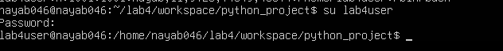

* sudo\_whoami.png

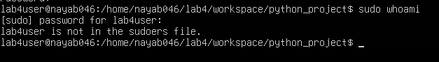

* exit\_back.png

C:\Users\sweng\OneDrive\Pictures\Screenshots\New folder\exit_back..png

## Bonus Task 7 – Create a small demo script using an editor and run it

* nano\_run\_demo.png

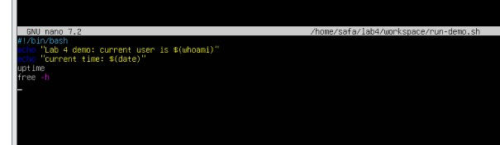

* run\_demo\_output.png

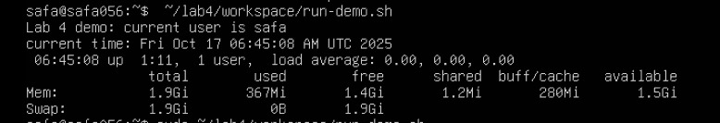

* run\_demo\_output\_sudo.png (optional)

